Director of Music

St John the Divine, Kennington

Vacancy Information Pack

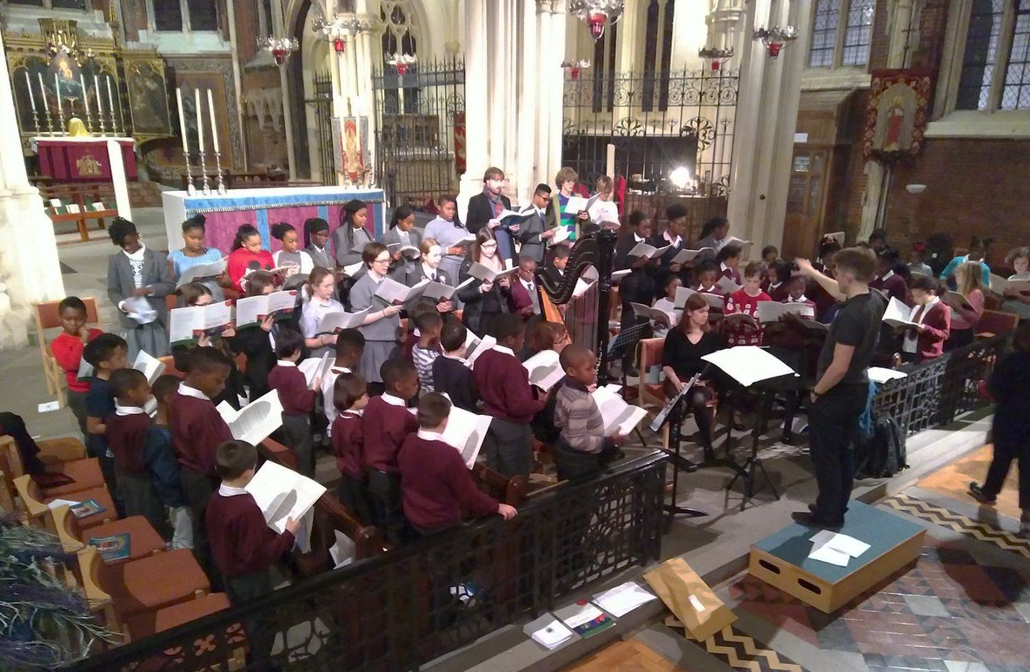

Closing Date: 15 April 2024

Interview Date: 23-24 April 2024
March 2024
Dear Candidate,

I am delighted that you have expressed interest in the role of Director of Music at St John the Divine, Kennington (SJDK).

Our Director of Music will be someone with a passion and flair for bringing the gift of choral music to young people from diverse and disadvantaged backgrounds, and making them part of our Church community. They will also work with and inspire our adult choristers, bring strategic direction to our music programme, and collaborate closely with our organist, music administrator, clergy and lay leaders in the parish.

Since its foundation in 1874, SJDK has brought the beauty of its Anglican catholic worship to its neighbourhood and nurtured the talents of some of the most disadvantaged young people in London. Our church has a large, diverse, and committed congregation, which reflects our community in Brixton, Camberwell and Kennington. Since the arrival of the Windrush, our congregation has included many people of Caribbean and African heritage. More recently we have welcomed a growing number of Latin American people. We are also a place of welcome and inclusion for LGBTQ+ people. It is important to us that our choirs reflect the diversity of our local community.

Music is central to our worship, mission and identity – as seen in this recent video. In 2013, we hired our current Director of Music to set up children’s choirs, recruiting choristers through singing workshops in local schools, with which we have strong links. We have over 80 young people singing every week across our four choirs – Boys’ and Girls’ Choirs, a mixed teenage Consort, and an Adult Choir. Our youth choirs rehearse every week during term time, and sing regularly for services, including with our Adult Choir and our two university-age choral scholars. Our adults sing most weeks, rehearsing before the Sunday Mass. We also currently have 5 piano students among our choristers, who are taught by our organist Edward Picton-Turbervill, some of whom we hope will transition to the organ.

Every summer, we take our Boys’ and Girls’ Choirs on a week-long residential to St John’s College Cambridge, with whom we have built a partnership. They sing for services in the College Chapel and a nearby Cathedral or the Cambridge Summer Music Festival. Our Consort also has an annual residential, taking part in Gabrieli Roar. Our choirs also sing in concerts in London; they will be in a performance of Tosca at SJDK in April 2024.

We are delighted that several of our choristers have won prestigious music scholarships, including to St John’s College and King’s College Cambridge, Westminster Abbey, and the Royal Academy of Music, with the help of our Director of Music. We are a parish which very much supports the training and flourishing of individuals, and we have a long track record of nurturing and developing young people, but also adults - lay and ordained. This also manifests itself in our resourcing church relationship with St Faith’s North Dulwich, and the Korean Anglican Church in New Malden.

The successful candidate will join us at an exciting juncture in our history. We are planning a major festival in 2025 to engage both the local community and the London music world. We are increasingly becoming a venue of choice for concerts, and are blessed with a fine Steinway model D piano. In April both our children’s and adult choirs will be involved in a performance of Tosca at the church. In 2025 will be installing a four-manual pipe organ, currently in use in St John’s College Chapel, Cambridge, and are amid a major fundraising campaign to pay for the organ’s renovation and installation. From this platform, we are determined to build on the success of our music tradition. In addition to our music administrator we are also recruiting a Director of Operations, so there will be strong operational support for the Director of Music.

If you feel inspired and called to this role, we would be delighted to hear from you. I would be very happy to informally discuss the role in advance of your application were that of value.

Yours sincerely,

Canon Mark Williams vicar@sjdk.org
Job Description

Job Title: Director of Music

Salary: £24,000 - £27,000 per year (£40,000 - £45,000 pro rata, depending on skills & experience)

Employer: St John the Divine Kennington

Hours: The duties and responsibilities equate to three days per week (i.e. approx. 21 hours) including at least three Sundays per month, and two residential courses per year. See Schedules A and B for further details. Extra duties will be undertaken by agreement.

Holiday Entitlement: You will receive 15 days annual leave per annum, to be taken during the school holidays, which include the weekends both sides of half-term.

Contract: Permanent, with 6-month probationary period

Base Location: St John the Divine, Kennington, 92 Vassall Rd, London SW9 6JA

Reporting to: The Vicar of St John the Divine, Kennington

Background: St John the Divine Kennington is a Church of England parish in the catholic tradition. Our community is rich in its diversity and open to all, regardless of race, gender, sexuality or background.

Job purpose: The Director of Music will lead our music programme. Through this, they will:

- Enrich our liturgy by leading our choirs in singing music of the Anglican and Catholic Choral Traditions.
- Bring the gifts of an excellent musical education and high-quality choral music to the young people of our neighbourhood, particularly those who would not otherwise receive them.
- Help to integrate our choristers and their families into our church community.
- Manage our Organist, Music Administrator and two student Choral Scholars.
- Promote SJDK and its facilities as a venue for music, including as a source of income for the church.
- Work closely with our clergy, staff and lay leaders to promote the SJDK’s wider strategy and mission.

Key Relationships: Vicar, Organist, Music Administrator, Director of Operations, Churchwardens, choristers and their families, local school staff.

Key Duties:

The role covers a wide range of responsibilities as outlined below. These may be adjusted from time to time as required, in negotiation with the Vicar.

- Subject to the general direction of the Vicar, be responsible for the care and oversight of all the music in the church, ensuring that it is in line with liturgical practices and the expectations of the Parish.

- Recruit, train and develop the Boys’, Girls’, Consort and Adult choirs to sing for the liturgy at St John the Divine, Kennington, following a cathedral-style repertoire, directing (or overseeing the direction of) the choirs in services as per Schedule A below.

- Direct or oversee rehearsals (a) midweek every week during term-time for each of the Boys’, Girls’, and Consort Choirs; (b) before each service as necessary for participating choirs.

- Ensure that the music programme complies with SJDK’s Safeguarding policy, and that a strong safeguarding culture is maintained.

- Develop opportunities for all choirs to sing outside the parish, including on residentials, and in relation to the link with St John’s College, Cambridge, as per Schedule B below.

- Where appropriate, in collaboration with other staff and volunteers, assist choristers from relatively deprived backgrounds with finding and grasping external opportunities (e.g. scholarships).

- Maintain and develop relationships with local schools, including the two parish schools, St John the Divine Primary and St Gabriel’s College, and work closely with staff at schools to develop a collaborative approach to supporting choristers, ensuring streams of recruitment and mechanisms for referring pupils to the choirs.

- Work closely with parents and volunteers, encouraging their support of the choirs.

- Communicate regularly with parents, schools, and other stakeholders as appropriate, in collaboration with other staff and volunteers, promoting the choirs in the community.

- Work closely with the Vicar, parish staff and PCC to ensure that the choirs and choristers are integrated into the life of the parish.

- Be responsible for researching, selecting, and preparing Music Lists of appropriate choral music for services in collaboration with the Vicar, and distributing them appropriately, well in advance of the listed services. The Vicar will select the hymns.

- Be responsible for arranging cover of suitably skilled deputies for periods of agreed absence.

- Line-manage the Organist and Music Administrator, and supervise the contribution of contractors, and volunteers to the musical life of the church.

- Engage the service of suitable instrumentalists as required, in agreement with the Vicar.

- Encourage use of the church by external users for musical rehearsals, concerts and recitals, to generate income for the church and enhance its reputation as a musical hub.

- Collaborate with the Organist in the development and running of the keyboard studentship scheme and vocal tuition.
- Manage the development and running of the Choral Scholarship scheme. This will include recruiting, coordinating with and developing the Choral Scholars.

- Be responsible for managing the budget for music.

- Work with the Vicar, staff and PCC on fundraising and the project to install a new organ, including providing material for grant applications and the preparation of feedback reports to funders.

- Help to create promotional materials for the music programme, in collaboration with other staff and volunteers where relevant.

- Undertake own administration and correspondence and attend relevant meetings as required.

- Attend meetings of the PCC and its sub-committees as requested when relevant matters are to be discussed.

- Foster a culture within the choirs that supports the mission and values of the church – in particular, encouraging collaboration, integration and progression among the choirs.

- Build and engage with a network of external contacts to promote and enhance the musical life of the church.

- The Vicar and Director of Music will meet monthly apart from August, often with other staff or Churchwardens, and consult on matters relating to music in the church and wider parish.

Person specification:

Essential

- An excellent musician and choral practitioner who inspires young people.

- The ability to teach people from a diverse range of backgrounds and of differing levels of experience of music and faith, and to command their respect.

- A strong desire to give a first-class musical education to those who would not necessarily have the opportunity.

- A good knowledge and understanding of the place of music within the liturgy.

- Experience of leading a choir in a relevant context.

- Good keyboard skills, though it is not essential to play the organ.

- A strong understanding of, and commitment to, safeguarding.

- Enthusiasm for the mission of SJDK, and sympathy for the ethos of the Anglican Church.

- An entrepreneurial attitude to improving our music programme and enhancing the church’s mission.

- The ability to work collaboratively with others, including musicians, clergy, parents, teachers, parishioners and external stakeholders.

- Strong interpersonal and communication skills, recognising that they will be working with choristers, volunteers and staff from diverse backgrounds and of different levels of experience of music and faith.

- Good management skills

- IT literacy

Desirable

- Graduate level qualification in music or equivalent

- Proficiency in Spanish and/or Portuguese

Equal opportunities, Anti-Racism & LGBTQ+
St John the Divine is committed to achieving equal opportunities in the way we deliver services to the community and in our employment arrangements. We expect all employees to understand and promote this policy in their work, and to be committed to the flourishing of all people in our diverse community.

Safeguarding
St John the Divine is committed to safeguarding and protecting the welfare of all children, young people and vulnerable adults, and expects all staff and volunteers to regard Safeguarding as paramount. An enhanced Disclosure & Barring Service (DBS) check is a requirement of this post.

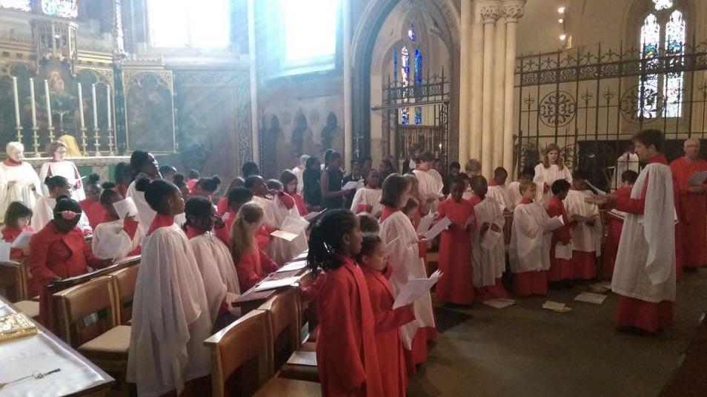

SCHEDULE A – Typical schedule, subject to flexibility in consultation with the Vicar and Organist

 | Choir | Conductor
Sunday Mornings
Week 1 | Girls + Adults | DoM or Organist
Week 2 | Boys + Adults | DoM or Organist
Week 3 | Consort + Adults | DoM or Organist
Week 4 | Adults | DoM or Organist
Week 5 | Flexible | DoM or Organist
 |  | NB: DoM at least 3 Sundays per month
Weekday Rehearsals
Tuesdays | Boys | DoM
Wednesday | Girls | DoM
Wednesday | Consort | DoM
Evensongs
Approx. one per term | Girls + Boys + Consort + Adults | DoM
Special services
Advent Carol Service | Adults + others as appropriate | DoM
Nine Lessons & Carols | G+B+C+A | DoM
Midnight Mass | Adults + others as appropriate | DoM
Christmas Day | Adults + others as appropriate | DoM
Epiphany Carol Service | Adults + others as appropriate | DoM
Joint Vespers with Sacred Heart Catholic (late January) | Consort | DoM
Ash Wednesday | Adults + others as appropriate | DoM
Holy Monday | Adults + others as appropriate | -
Holy Tuesday | Adults + others as appropriate | -
Holy Wednesday | Adults + others as appropriate | -
Maundy Thursday | Adults + others as appropriate | DoM
Good Friday pm | Adults + others as appropriate | DoM
Easter Vigil | Adults + others as appropriate | DoM
Friends Mass (1st Saturday in May) | Adults + others as appropriate | DoM
Ascension Day | Adults + others as appropriate | DoM
All Souls’ Day | Adults + others as appropriate | DoM
No choral services:
Christmas 1
Easter 2
August (post-Cambridge residential) to 1st Sept

SCHEDULE B – Other events

- Annual residential with Boys’ and Girls’ choirs (six days, late July)

- Annual residential with Consort Choir (A few days, date flexible)

Additional services, concerts or residentials as agreed in consultation with the Vicar.
